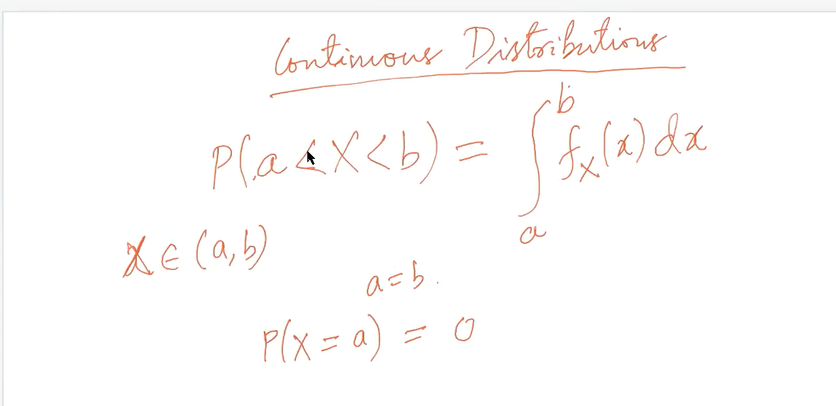Probability distribution for continuous Random variable:

Here the random variable can take values in between a and b.

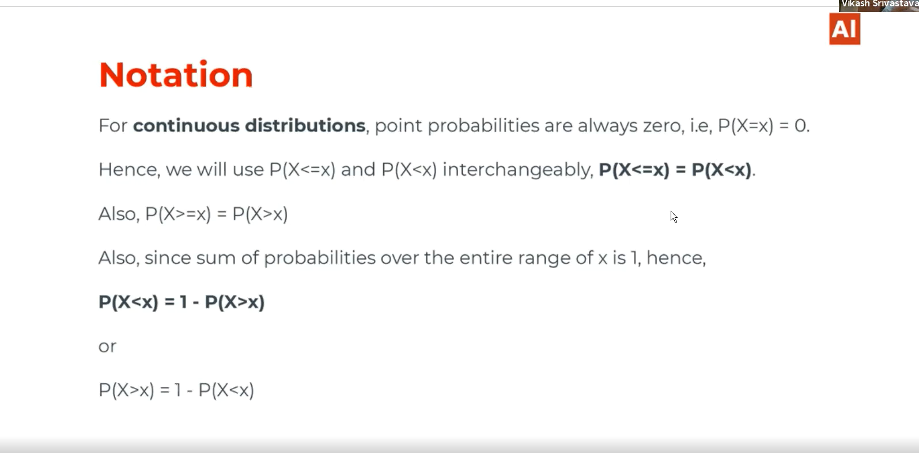

# The example of uniform distribution by taking one example:

In numpy we had seen a method np.random.random() 🡪 it uses continuous uniform distributions and it will take values from 0 to 1 which is considered as a to b.

Np.random().rand 🡪 Uses Discrete uniform distribution function.

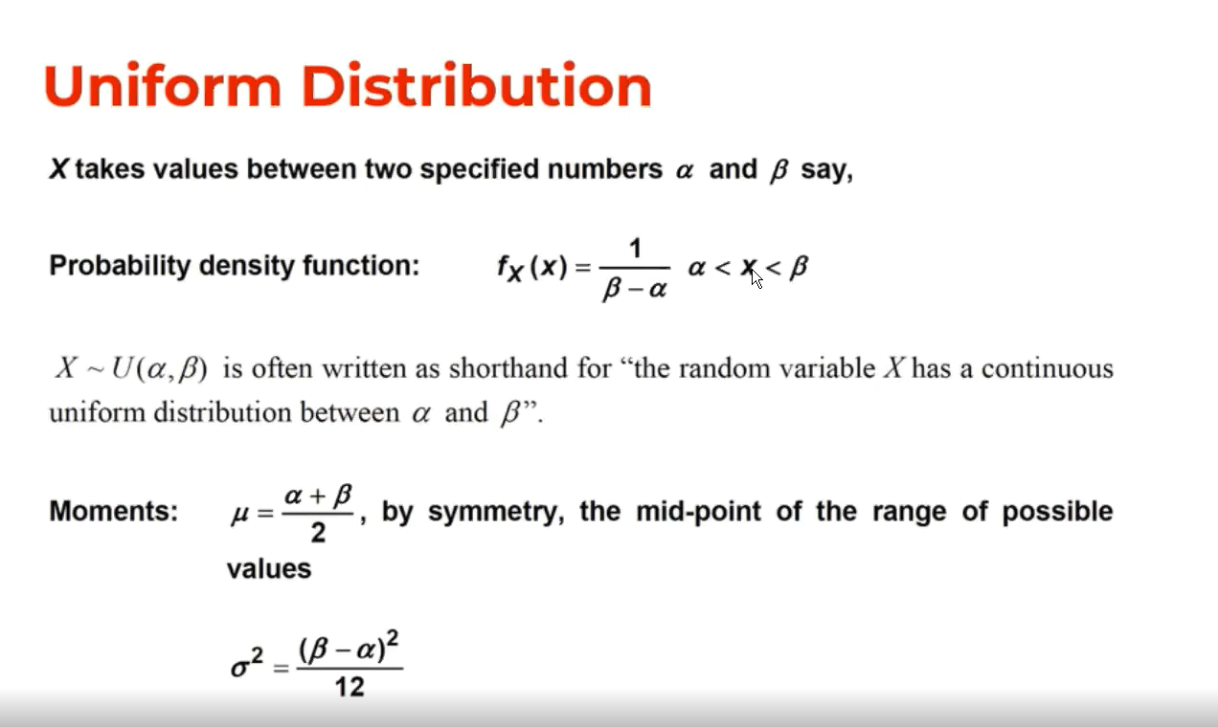

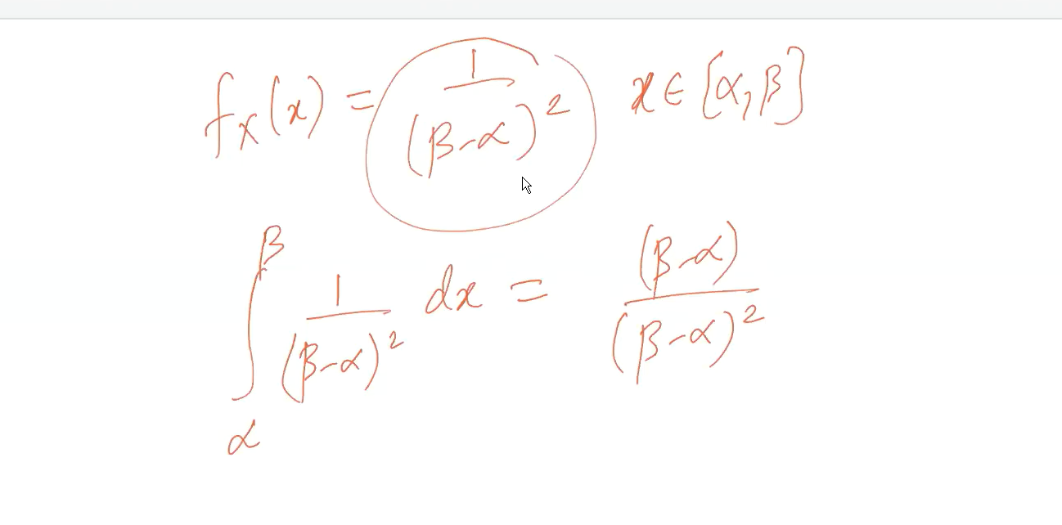

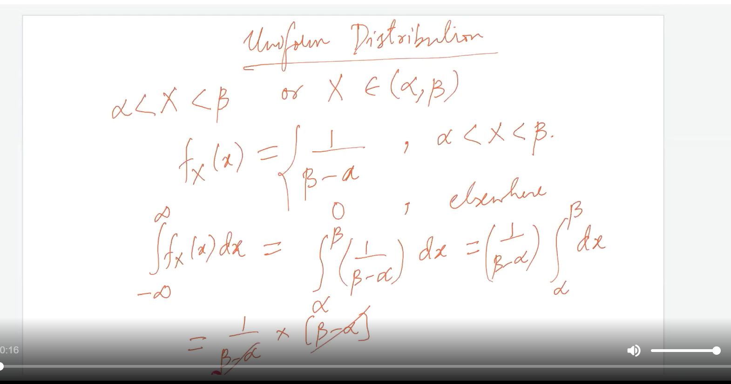

# Expected value for uniform distribution:

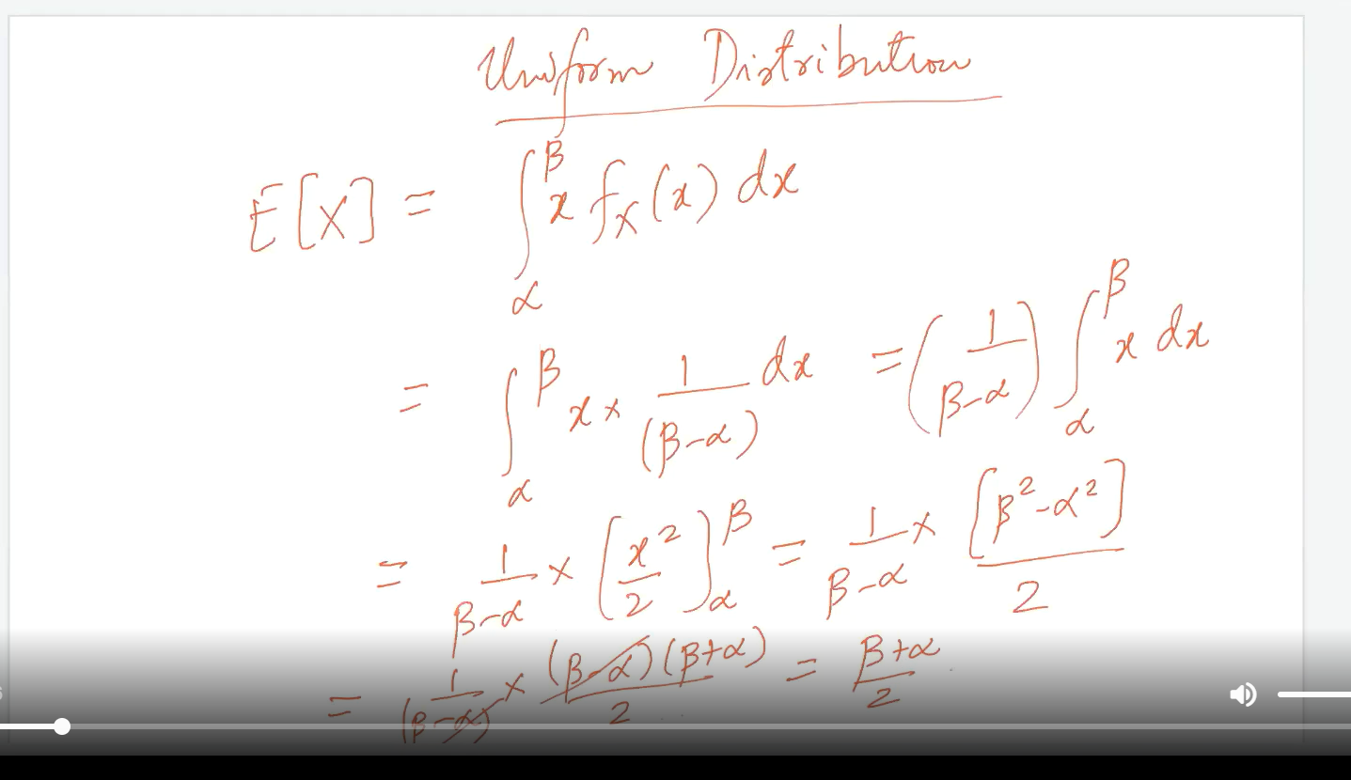

# Mean and variance for uniformly distributed random variable:

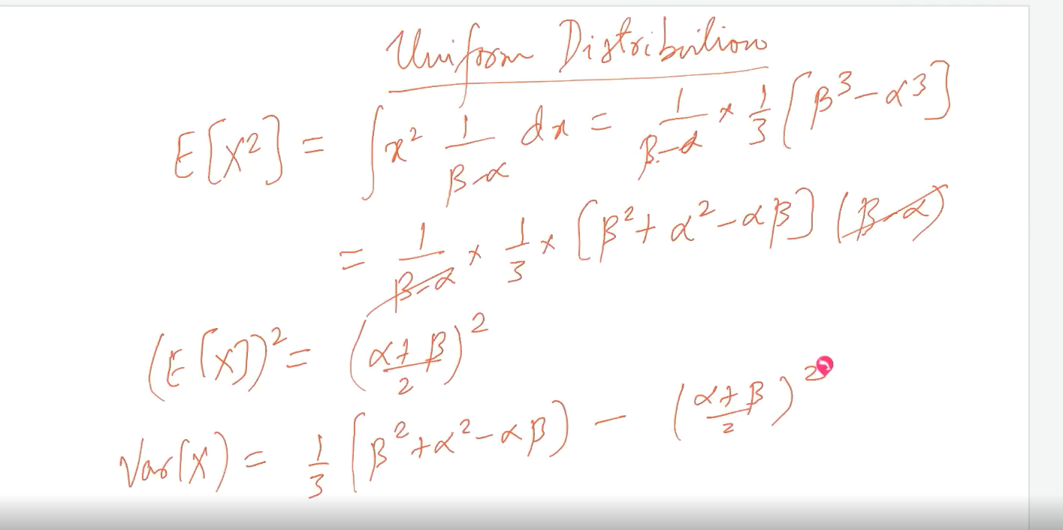

# CDF of uniformly distributed random variable:

At Alpha cdf==0 at beta cdf==1 and in between alpha and beta the cdf get vary.

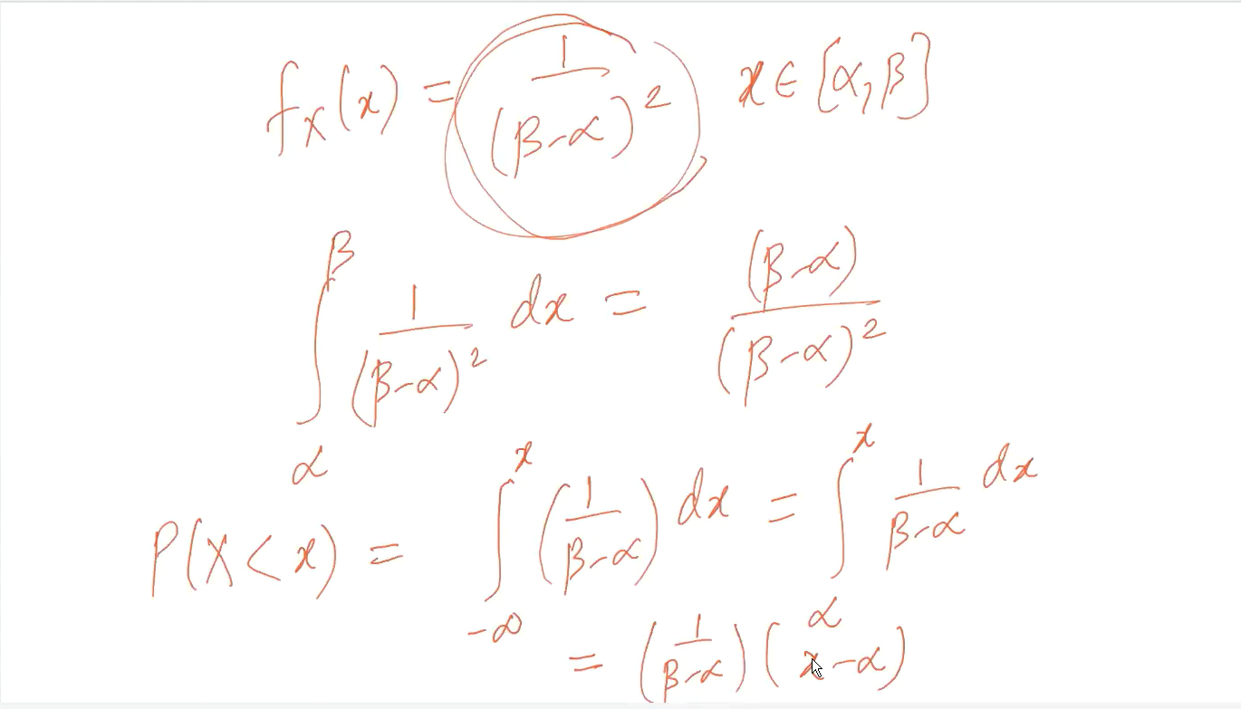

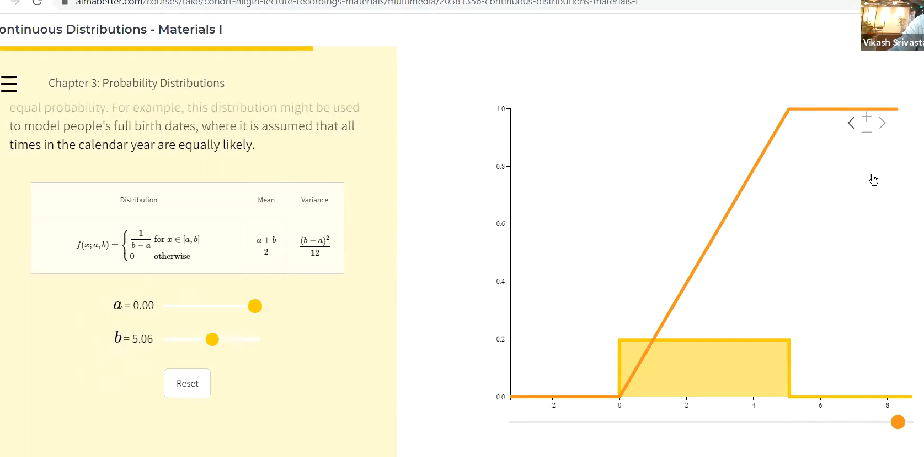

# Normal distributions:

Height v/s count of people.

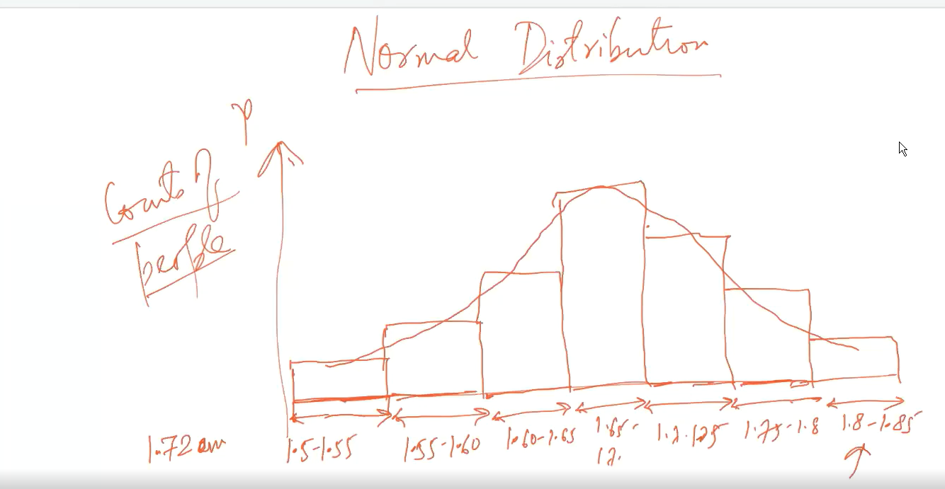

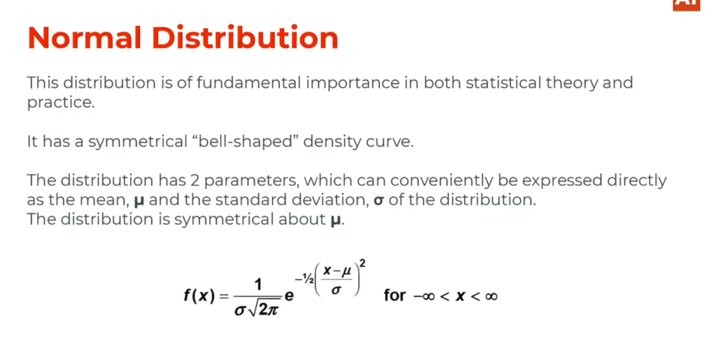

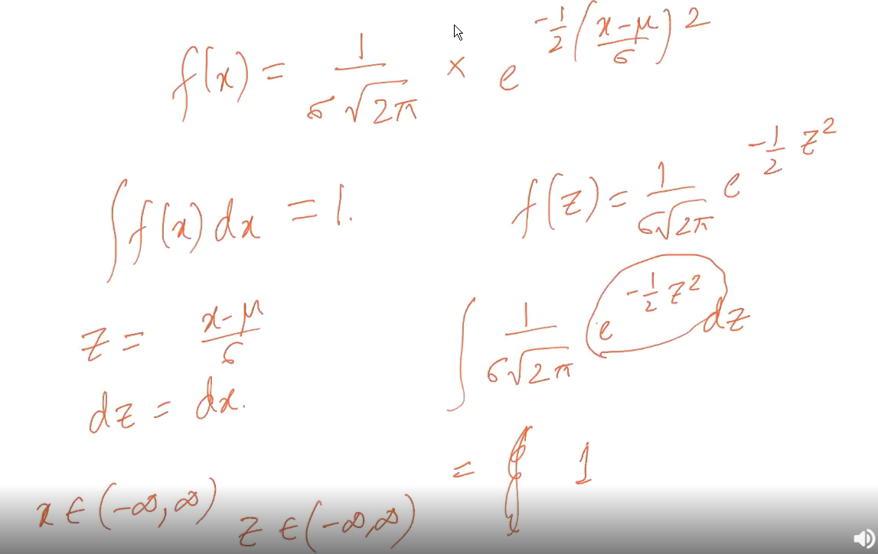

Properties of Normal distribution:

🡪Symmetrical about the mean

🡪Asyymptotatic 🡪Tails of the curve Never touches to x-axis

🡪Bell shaped curve

# Standard Normal distribution:

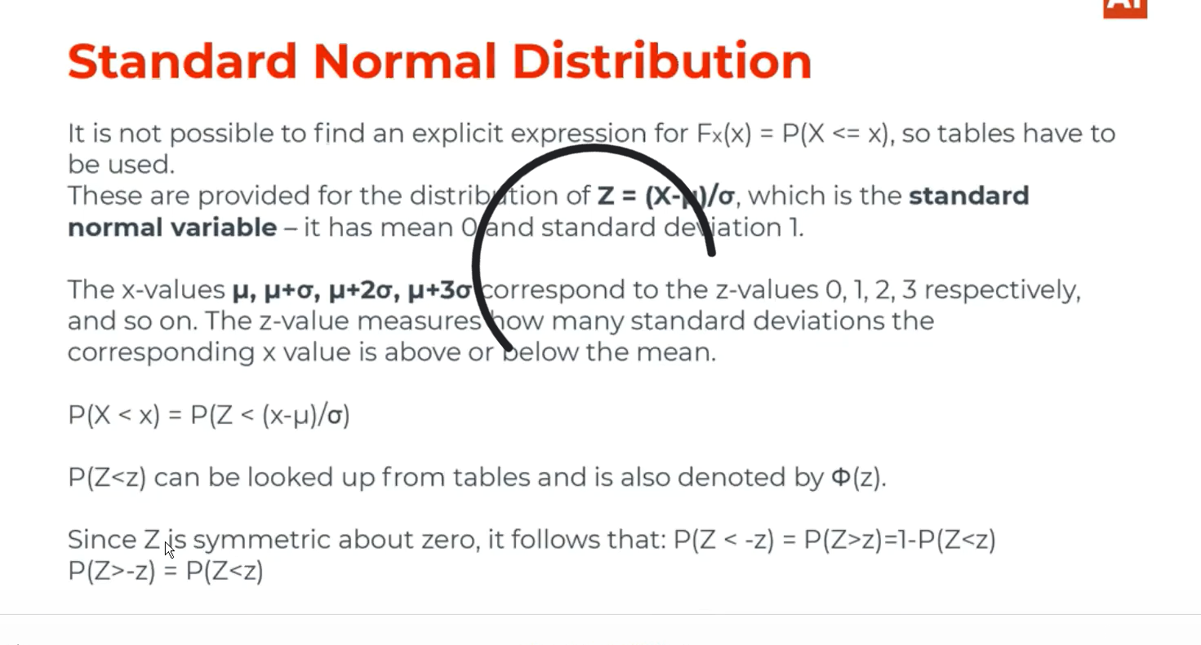

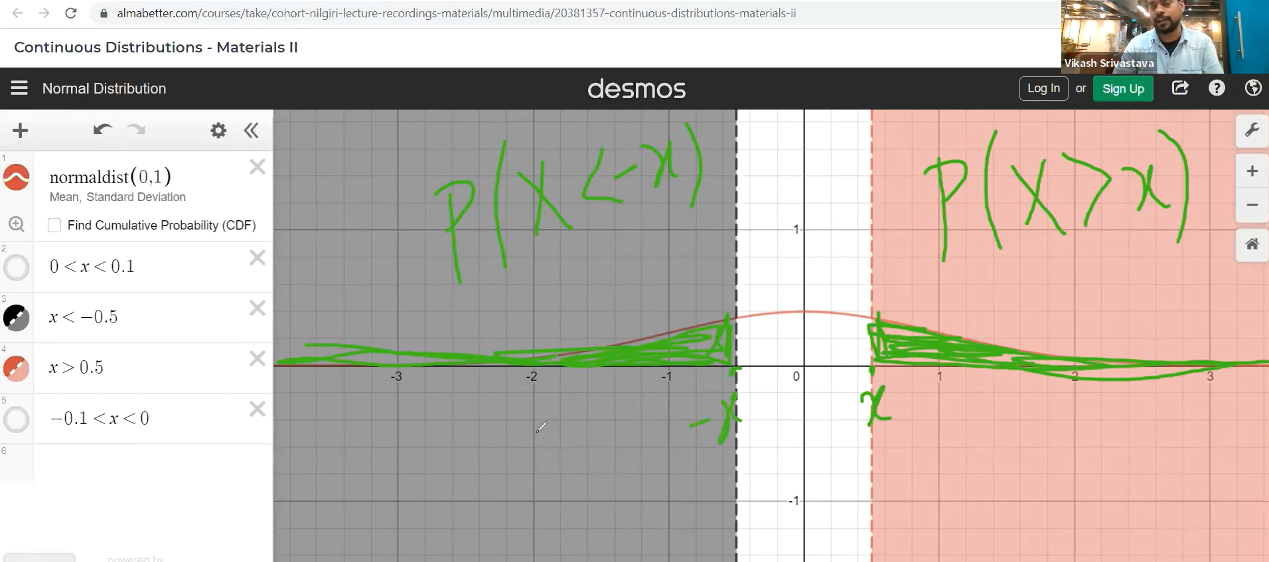

# Exponential distribution:

Its used to model the waiting period. It’s a continuous analogue of geometric distributions.

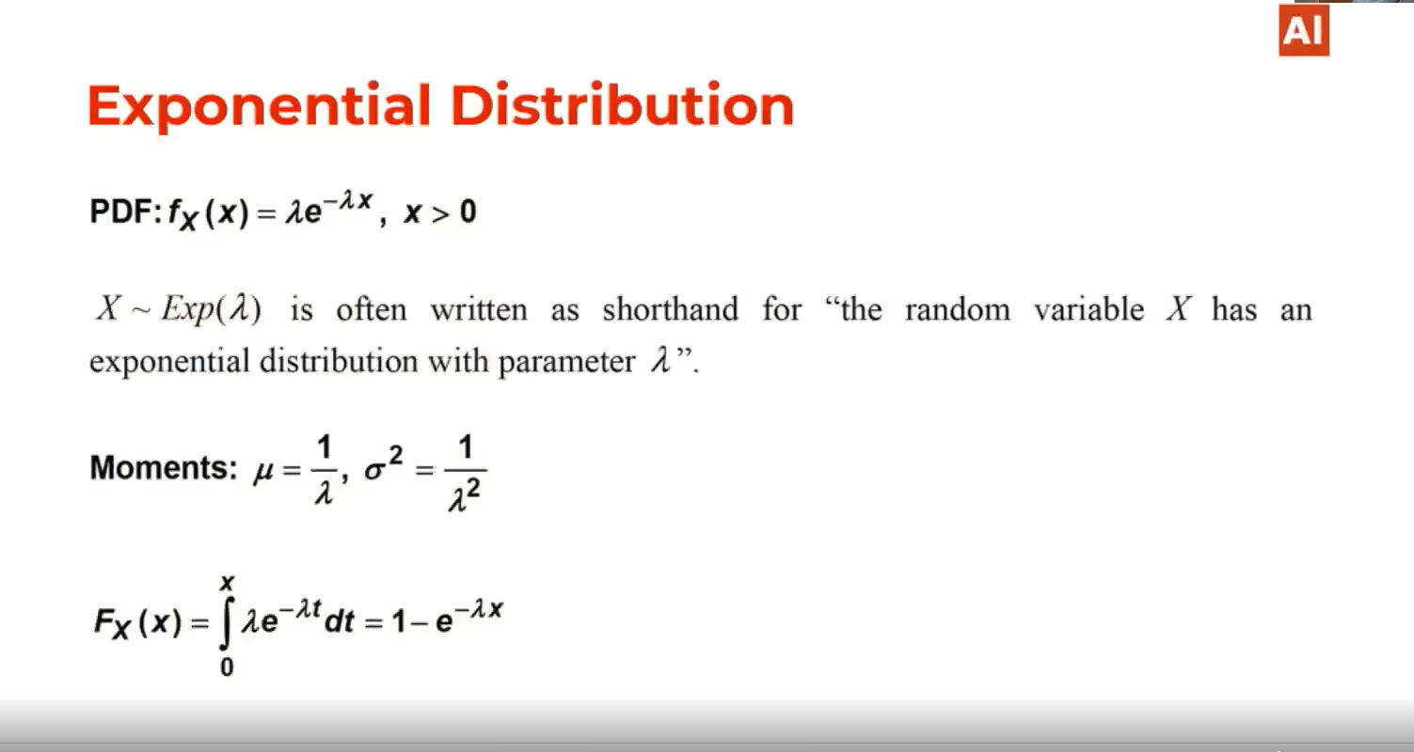

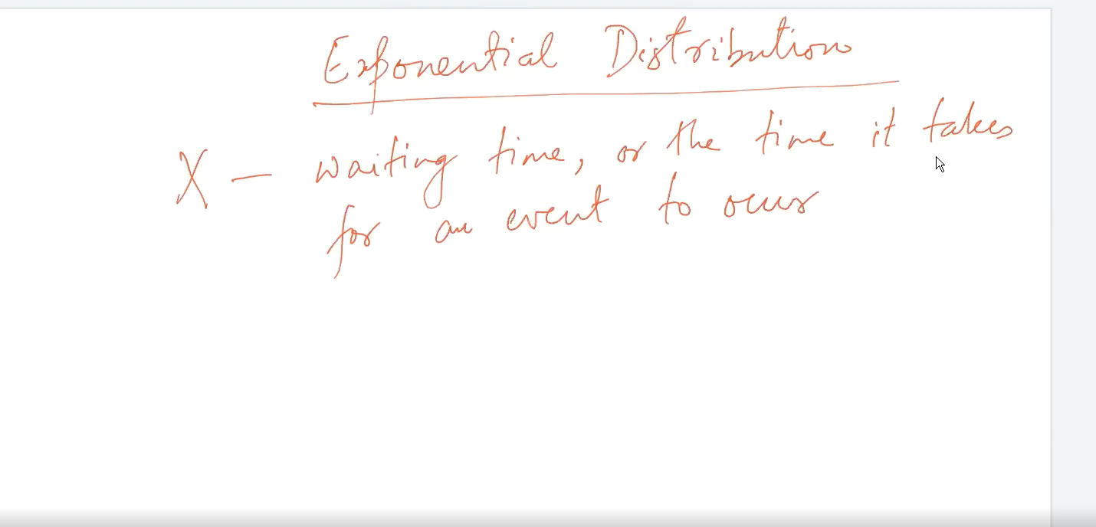

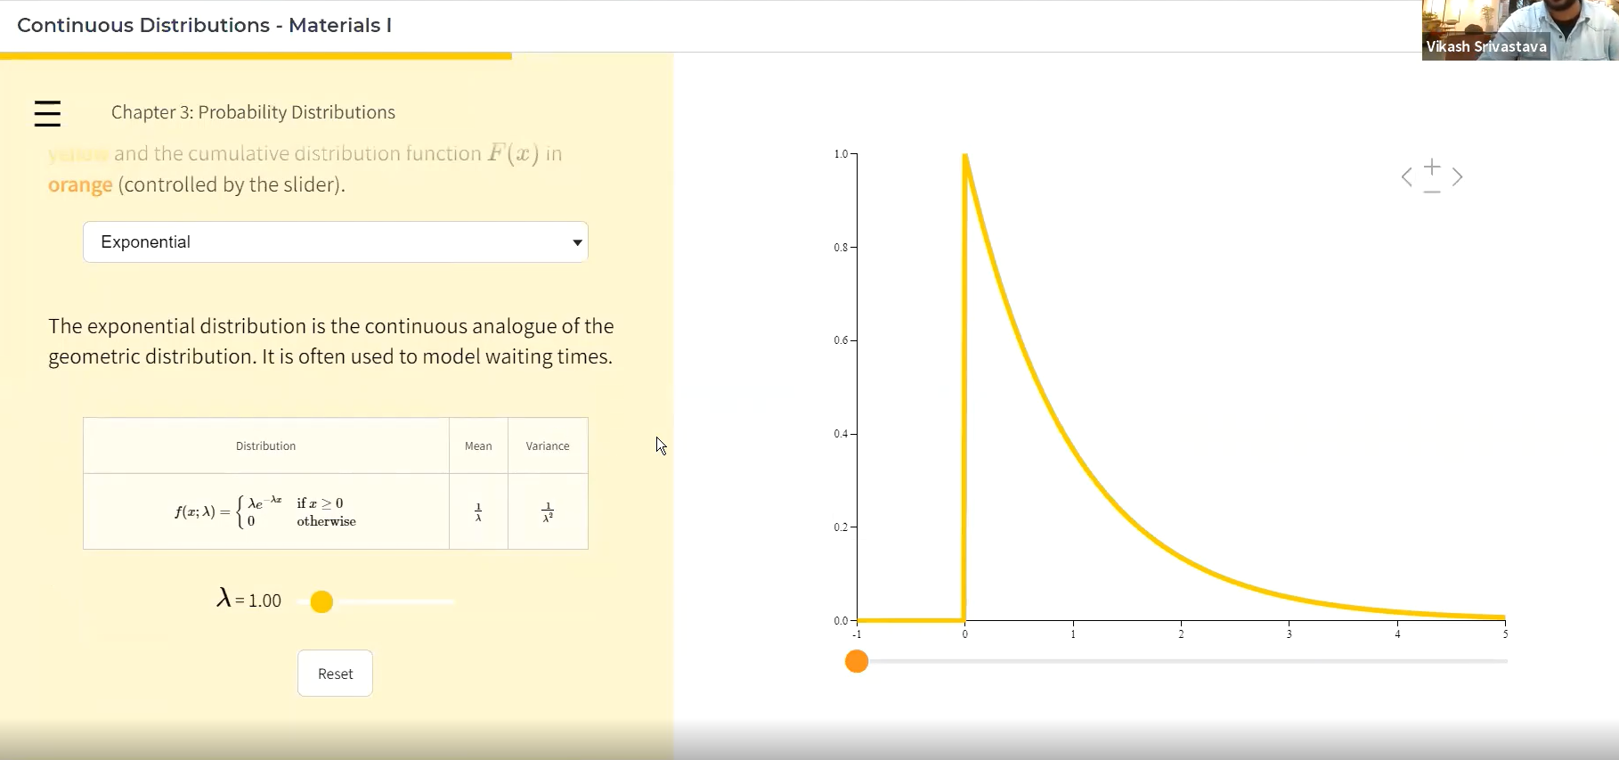

# Exponential and Poisson distribution relation:

